**Relational Schema**

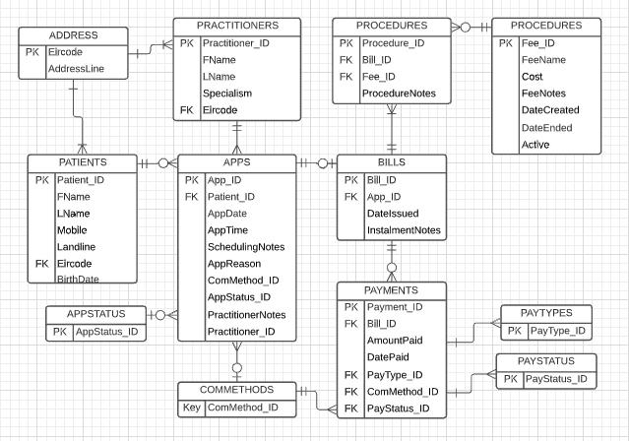

**Table explanations:**

**ADDRESS**: Basic address details for patients or practitioners.  
**APPS**: Numeric auto-incrementing appointment ID. An appointment can be in-house representing a referral. If in-house, all information should be

Appointments are generally booked either for in-house session or external sessions. They capture any topline details also for the session.  
**APPSTATUS**: For future and finished appointments, the status remains booked. If there is a no-show or someone is late, this can be ‘Late Cancellation’. If someone has a booked appointment but expressed being notified for an opening/cancellation, an additional appointment can be made for them with ‘Seeking Opening’. This may then be search after each confirmed cancellation. Details of cancellation or seeking an opening can be kept in the SchedulingNotes.

**BILLS**: A bill is generated only when an appointment takes place or if a late cancellation penalty is generated. Details on any instalments can be captured here also.

**COMMETHODS**: How an appointment was arranged or a payment was made whether it be by phone, in-person or by post. Payment in the original narrative excluded ‘by phone’, however, this allows for card details to be given for over-the-phone payments.

**FEES:** This is the costing table for each type of procedure that can be done. All costings can be made active/inactive and given a start and end date to assist sorting by what charges apply historically and which are actively applicable.  
**PATIENTS**: Clients of the dental practice and their contact details.  
**PAYMENTS**: A payment may be a full or partial payment per bill. It may be paid on the day of treatment or afterwards.  
**PAYSTATUS**: This allows for any issues that may arise with cheques if ‘Denied’ or ‘Awaiting Confirmation’. Imaginably, card and cash payments can be confirmed as ‘Complete’ on the spot.  
**PAYTYPES**: Provides for cheque, card and cash payments.

**PRACTITIONERS**: This includes Dr. Mulcahey and a list of the external partner practitioners for referral.

**PROCEDURES**: Procedures are instances of work done in an appointment.